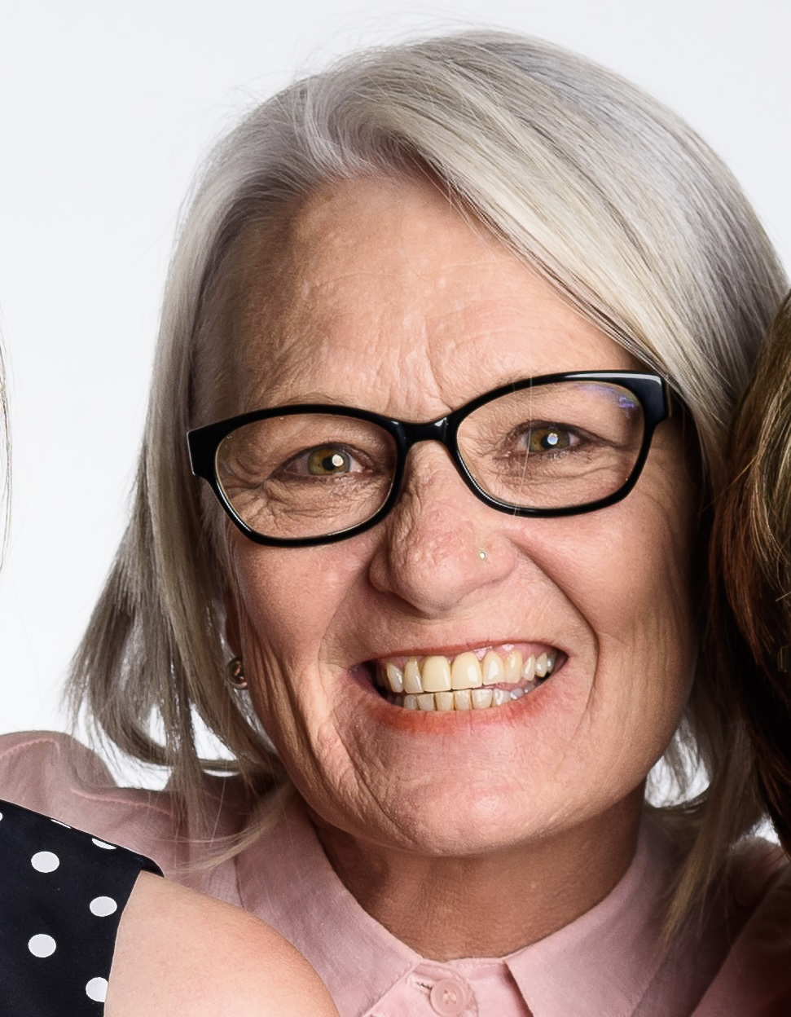

The Philippa Campbell Fellowship for Older Women

About Philippa Campbell
Phillipa Campbell was a wonderful woman who was passionate about respect for older people, equality for women and human kindness. Philippa dedicated much of her life to working with older people, including as CEO of Elder Rights Advocacy, Victoria.

Philippa died in 2023, when she was just 56 years of age. We want to celebrate Philippa’s life and the contribution she made to making the world a better place.

The Philippa Campbell Fellowship is an annual Fellowship for older women to work on a project combatting the inequalities older women face. The Fellowship sits within the Elder Leadership Academy.

Information about the Philippa Campbell Fellowship is presented on the following pages.

About Celebrate Ageing
Celebrate Ageing Ltd is a not-for-profit organisation established in 2013 to combat ageism and build respect for older people. Our work focuses on culture change, and we are passionate about modelling or showing respect for older people across all our programs.

About the Elder Leadership Academy
The Elder Leadership Academy is at the heart of Celebrate Ageing. The Academy provides Fellowships for older people to co-lead projects combatting ageism and building respect for older people. The Fellowships move beyond traditional approaches of working with older people i.e.: representation, consultation, co-design and co-production. We recognise older people have the skills and passion to co-lead change and transform their own world.

Most Fellowships focus on issues of marginalisation and social justice experienced by older people. The Philippa Campbell Fellowship focuses solely on older women. Go to our webpage to read about our current and past Fellows and their achievements, at: celebrateageing.com/academy

About the Philippa Campbell Fellowship
The Elder Leadership Academy is offering an annual Philippa Campbell Fellowship to older women (65+) to combat the inequalities for older women. Older women are devalued and experience significant disadvantage at the intersections of ageism and sexism and are:
- the lowest income earning family group (see here)
- the largest group of unpaid carers-70% of carers are women (see here)
- the fastest growing group of homeless - increase of 31% for 2011-2016 (see here)​
- more likely to live in poverty - 34% of single older women live in poverty (see here)
- more likely to experience workplace discrimination (see here)
- more likely to experience Elder Abuse than men (see here)
- more likely to be sexual assaulted (see here).

Fellowships are limited to older women who meet the successful applicant characteristics listed below and whose projects fit within Celebrate Ageing’s strategic plan and work capacity.

Successful applicants must have:
- An inequality for older women they wish to change
- Ideas about strategies for change related to inequalities for older women
- Capacity to influence others
- Willingness to engage key stakeholders
- Passion for culture change – and time to dedicate to making change happen
- Willingness to reflect on opportunities to improve
- Commitment to inclusion of older women who are marginalised
- Commitment to work as a team
- Commitment to respect for all people
- Willingness to combat their own internalised ageism.

Successful applicants will be supported to:
- Document a project plan: the need, aims, actions, outputs, expected outcomes
- Identify any sources of funding required (please note Celebrate Ageing does not have capacity to fund projects or Fellowships)
- Identify key stakeholders and allies
- Document a risk management plan
- Implement and evaluate the project
- Document a brief community report.

Funding
Celebrate Ageing does not have funding to support projects or Fellows. If funding is required for project activities, please identify sources of project funding and discuss with us how you believe funding could be sought.

Inclusion
Celebrate Ageing is committed to inclusion of people who are marginalised. This includes First Nation’s People, CALD, LGBTI, people living with dementia etc.

Accessibility
We are committed to ensuring the Fellowships are accessible. If you are an older woman with English as a second language, if you are Deaf, Vision Impaired, have dementia or different learning/working styles – please let us know how we can the Fellowships accessible for you.

Expectations
Celebrate Ageing values include ageing, respect, inclusion, equality and compassion. Fellows must also demonstrate commitment to these values. Celebrate Ageing reserves the right to withdraw Fellowships (including after graduation) if these values are not upheld by the Fellow.

Fellows have the right to withdraw from their Fellowship if their expectations are not met. We welcome all opportunities to clarify expectations and any opportunities to discuss concerns they are not being met.

Intellectual property
We believe it is important to profile the work undertaken by Fellows and we ask that Fellows acknowledge that their work was undertaken as part of a Fellowship with the Elder Leadership Academy. It’s about reciprocal recognition.

Before applying
Here are the questions that are included in the Fellowship Application Form. It is important that you call Academy Coordinator Dr Catherine Barrett to discuss your application before completing the application form – call 0429 582 237.

- The problem/need
  - What is the problem for older women that you have identified?
  - What else has been done to address this problem?

- Aims and objectives
  - What do you want to achieve for older women?
  - How will you address the problem older women are experiencing?

- Key activities
  - What are the steps that you will take?
  - What will you do?

- Risk management
  - What are the risks of doing this work?
  - How will you reduce the risks?

- Stakeholders
  - Who are the key stakeholders and allies you can contact for support?
  - Who else needs to be engaged?

- Timelines
  - How long will your project take?
  - How much time will you dedicate to your project?

- Funding
  - Does your project require funding (if so, for what?)
  - What sources of funding have you identified?

- Support
  - What support do you want from Celebrate Ageing for your project?
  - What other support do you need and from whom?

- Outputs
  - What will your project produce?
  - What others see from your project?

- Outcomes
  - What do you expect will change as a result of your project?
  - How will you evaluate (measure or describe) the changes?

