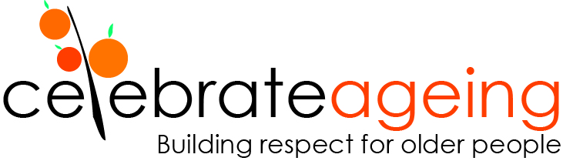

Gen K and Kidney Kindness, Max Primmer
Fellowship with the Elder Leadership Academy

Title: Gen K and Kidney Kindness
Fellow: Max Primmer
Date: 2023 – current

Context
Chronic kidney disease increases rapidly with age, affecting around 44% of Australians aged 75+. The number has doubled and the number of hospitalisations for dialysis has tripled - around 14% of hospitalisations are for dialysis. Dialysis costs around $85-$125,000 per person per year. Indigenous Australians are hospitalised for dialysis at a rate over 10 times as high as that for non-Indigenous Australians and are almost four times as likely to die with chronic kidney disease as a cause.

For people on dialysis there are high rates of mental health issues and poor quality of life. The research also shows that although twice as many women than men on dialysis are diagnosed with depression, twice as many men than women suicide.

Men more often adopt avoidance as a coping strategy and can find it difficult to express their fears in response to the social pressure/expectation of them being tough, strong, and responsible for the economy of the household. The stuff that is tough for men of a certain age is that they are used to expressing their masculinity in a particular way.

Some have been the bread winner their whole life and suddenly, they aren’t. They can’t do that role anymore. They feel weak. Some feel emasculated. It affects their masculinity – they might not be sure who they are anymore. That’s where the mental health issues from.

The Kidney Kindness project will document men’s gendered responses to dialysis and develop simple strategies to support their adjustment. The Kindness aspect of the project reflects the importance of kindness in my life. In 2009 my kidneys failed suddenly, and I required renal dialysis. In 2012 I became the grateful recipient of a kidney donation. Kindness has always been important in my life.

The Kidney Kindness project will be part of the Gen K intergenerational workshops hosted in Hepburn (a town in regional Victoria). I will assist in overall coordination of these workshops, which include focusing on internalised ageism (kindness for self) and intergenerational kindness collaborations.

Aims and objectives
The primary aim of the Gen K – Kidney Kindness project is to support older men’s adjustment to renal dialysis. An additional aim is to help shape workshops to combat internalised ageism. Both these aims will be achieved through Gen K workshops facilitated in the Hepburn Community.

Activities
- Assist in coordinating gatherings (called Saving7) for older people living in Hepburn who are participating in Gen K workshops - to explore internalised ageism prior to the intergenerational collaborations
- Assist in coordinating the Gen K workshops in Hepburn
- Work with a younger person/s in the Gen K workshops to undertake acts of kindness for people on renal dialysis
- Document the gendered experiences of men receiving renal dialysis
- Develop simple strategies to support men to adapt to renal dialysis
- Encourage community members to sign up for organ donation.

Outputs: tbc

Outcomes: tbc

Partnerships and acknowledgements: tbc

Links: tbc

